Link Social flow

Flow diagram
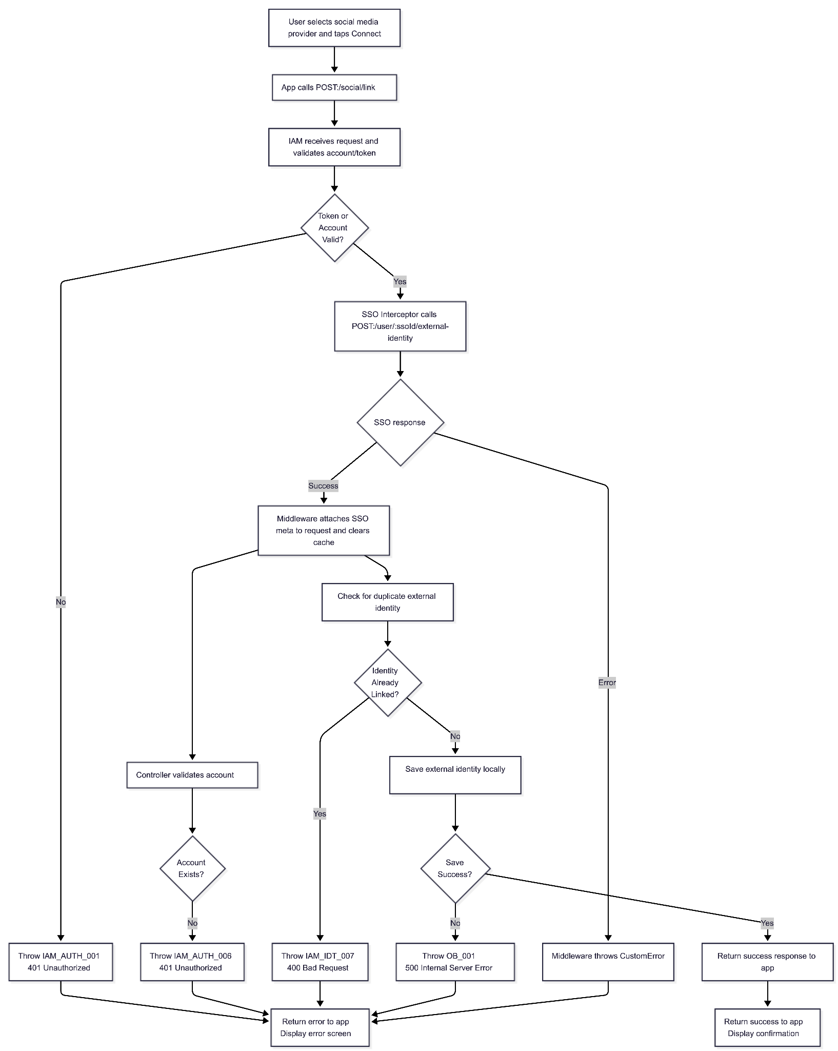

Preview Screen
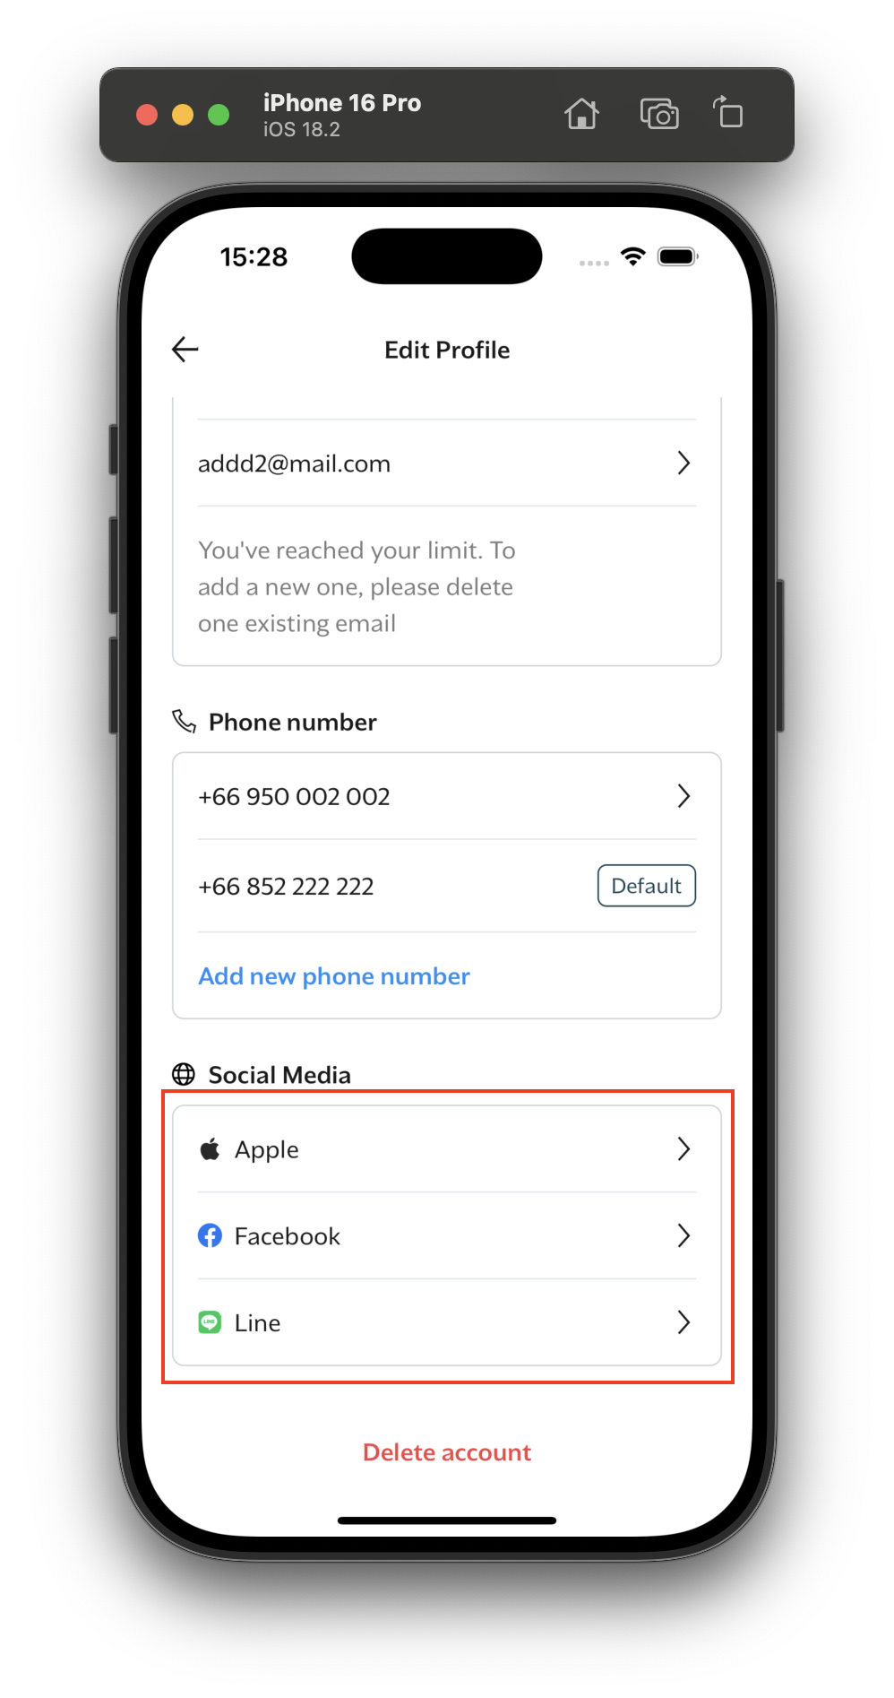

Sequence diagram
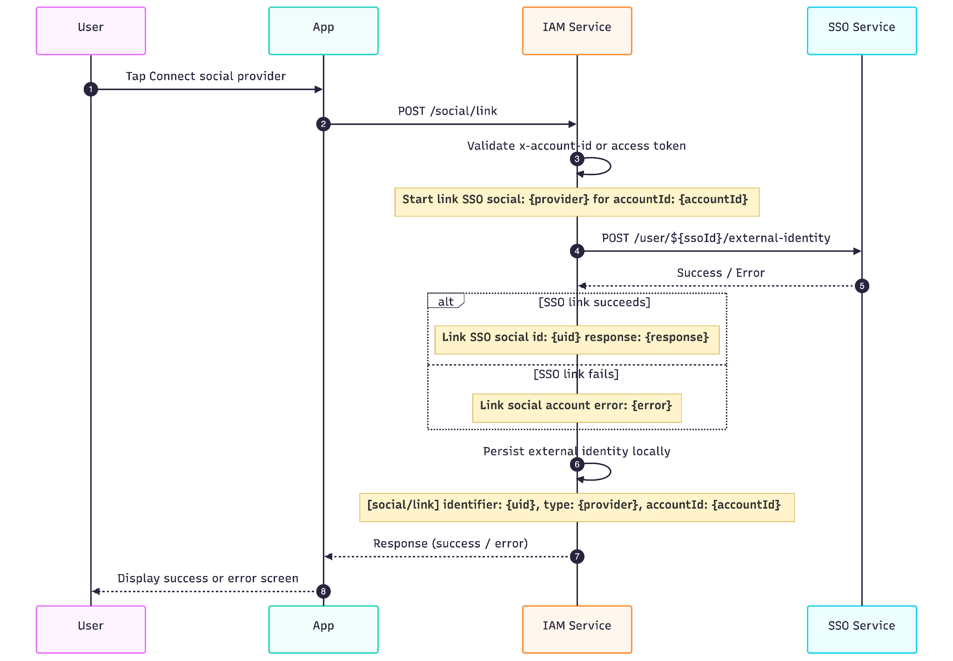

Api description

IAM service

Description
Link a social external identity to the current account

Example Request

POST /social/link HTTP/1.1
Content-Type: application/json
x-account-id: abc-1233-def
x-access-token: eyJhbGciOiJIUzI1NiIsInR5cCI6IkpXVCJ9...
app-version: 1.0.0
{
"provider": "facebook",
"uid": "1234567890",
"meta": [
{
"id": "ext_123456789",
"provider": "facebook",
"value": "1234567890"
}
]
}

Headers
Name | Required | Description
x-account-id | Optional | Current account ID when available
x-access-token | Optional | Bearer auth token when account ID is not provided
app-version | Recommended | Used by SSO interceptor to decide whether SSO is required

Request Body
{
"provider": "facebook",
"uid": "1234567890",
"meta": [
{
"id": "ext_123456789",
"provider": "facebook",
"value": "1234567890"
}
]
}

Name | Type | Required | Description
provider | string | Yes | Social provider type, e.g. facebook, apple, line
uid | string | Yes | External social user identifier
meta | object | No | SSO response data containing created external identity details (populated by middleware)

Example response
{
"data": true
}

Response detail
Result | Description
true | Link social success

Error Scenarios
Error Code | HTTP Status | Description | Cause | Resolution
IAM_AUTH_001 | 401 | Invalid or missing authentication token | Token validation failed or no token provided | Provide valid access token or account ID
IAM_AUTH_006 | 401 | Account not found | Account ID references non-existent account | Ensure user is logged in with valid account
IAM_IDT_007 | 400 | Duplicate external identity or failed social link | Social identity already linked to this or another account | Unlink the identity first or use different social account
IAM_SSO_007 | 400 | Missing SSO external identity for the account | IAM account has no linked SSO identity | Ensure account has been created via SSO
OB_001 | 500 | Unexpected internal server error | Database error or unexpected exception | Retry later

Error Response Examples

400 Bad Request - Duplicate External Identity
{
"error": {
"code": "IAM_IDT_007",
"message": "external identity already exists",
"stack": "Error: external identity already exists\n at SocialController.linkSocial"
}
}

400 Bad Request - Missing SSO Identity
{
"error": {
"code": "IAM_SSO_007",
"message": "external sso identity not found",
"stack": "Error: external sso identity not found\n at ssoInterceptor.linkSocial"
}
}

401 Unauthorized - Invalid Token
{
"error": {
"code": "IAM_AUTH_001",
"message": "invalid or missing access token",
"stack": "Error: invalid or missing access token\n at AuthService.validateToken"
}
}

401 Unauthorized - Account Not Found
{
"error": {
"code": "IAM_AUTH_006",
"message": "account not found",
"stack": "Error: account not found\n at SocialController.linkSocial"
}
}

500 Internal Server Error
{
"error": {
"code": "OB_001",
"message": "internal server error",
"stack": "Error: database connection failed\n at ExternalIdentityRepository.create"
}
}

SSO service

Example Request
POST /user/:id/external-identity
clientId: cd-123
clientSecret: ab-123
{
"value": "string", // The unique identifier from the social provider
"provider": "facebook|apple|line" // The external identity provider
}

Headers
Name | Type | Required | Description
clientId | string | Yes | Client identification key
clientSecret | string | Yes | Client secret for authentication

Path Parameter
Name | Type | Required | Description
id | string | Yes | The public SSO user ID (for example, sso_xxxx)

Request Body
Field | Type | Required | Description
value | string | Yes | The unique identifier from the social provider
provider | string | Yes | External identity provider: 'facebook', 'google', 'apple', 'line'

Example Response
{
"external": [
{
"id": "11111111-1111-1111-1111-111111111111",
"value": "abcde123456",
"provider": "line"
},
{
"id": "22222222-2222-2222-2222-222222222222",
"value": "facebook_user_id_12345",
"provider": "facebook"
}
]
}

Error scenarios
Status Code | Description | Error Code | Message | Example Error Response
400 | Bad Request | SSO_IDP_0010 | Duplicate external identity | {"error":{"code":"SSO_IDP_0010","message":"Duplicate external identity","stack":"..."}}
400 | Bad Request | SSO_IDP_005 | Can not link external identity | {"error":{"code":"SSO_IDP_005","message":"Can not link external identity","stack":"..."}}
401 | Unauthorized | OB_AUTH_001 | Invalid client credentials | {"error":{"code":"OB_AUTH_001","message":"Invalid client credentials","stack":"..."}}
404 | Not Found | SSO_ACC_002 | SSO ID not found | {"error":{"code":"SSO_ACC_002","message":"SSO ID not found","stack":"..."}}

Example Error Response

400 Bad Request - Duplicate Identity
{
"status": 400,
"error": {
"code": "SSO_IDP_0010",
"message": "Duplicate external identity",
"stack": "Error: Duplicate external identity\n at ..."
}
}

400 Bad Request - General Link Failure
{
"status": 400,
"error": {
"code": "SSO_IDP_005",
"message": "Can not link external identity",
"stack": "Error: Can not link external identity\n at ..."
}
}

Cache keys
Key | TTL | Source | Purpose
EXTERNAL_IDENTITY_CACHE_KEY_KEY_{accountId} | 3600 seconds | ExternalIdentityService | Stores external identity cache keys for the account so they can be invalidated together.
EXTERNAL_IDENTITY_CACHE_KEY_account_id_{accountId} | 3600 seconds | ExternalIdentityService.GetExternalIdentity | Cached external identities by account ID. Deleted after successful SSO social linkage.
EXTERNAL_IDENTITY_CACHE_KEY_identifier_{identifier} | 3600 seconds | ExternalIdentityService.GetExternalIdentity | Cached external identities by identifier. Deleted through the account key registry.
EXTERNAL_IDENTITY_CACHE_KEY_uid_{uid} | 3600 seconds | ExternalIdentityService.GetExternalIdentity | Cached external identities by external UID. Deleted through the account key registry.

